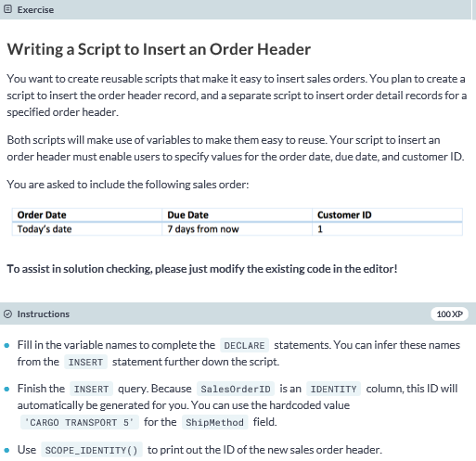

**DECLARE @OrderDate datetime = GETDATE();**

**DECLARE @DueDate datetime = DATEADD(dd, 7, GETDATE());**

**DECLARE @CustomerID int = 1;**

**INSERT INTO SalesLT.SalesOrderHeader (OrderDate, DueDate, CustomerID, ShipMethod)**

**VALUES (@OrderDate, @DueDate, @CustomerID, 'CARGO TRANSPORT 5');**

**PRINT SCOPE_IDENTITY();**

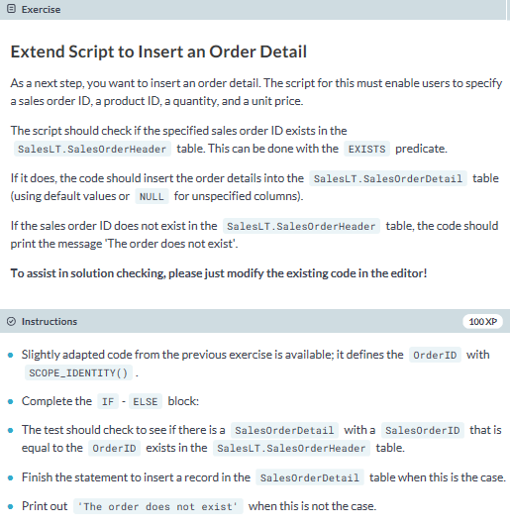

**-- Code from previous exercise**

**DECLARE @OrderDate datetime = GETDATE();**

**DECLARE @DueDate datetime = DATEADD(dd, 7, GETDATE());**

**DECLARE @CustomerID int = 1;**

**INSERT INTO SalesLT.SalesOrderHeader (OrderDate, DueDate, CustomerID, ShipMethod)**

**VALUES (@OrderDate, @DueDate, @CustomerID, 'CARGO TRANSPORT 5');**

**DECLARE @OrderID int = SCOPE_IDENTITY();**

**-- Additional script to complete**

**DECLARE @ProductID int = 760;**

**DECLARE @Quantity int = 1;**

**DECLARE @UnitPrice money = 782.99;**

**IF EXISTS (SELECT * FROM SalesLT.SalesOrderHeader WHERE SalesOrderID = @OrderID)**

**BEGIN**

**INSERT INTO SalesLT.SalesOrderDetail (SalesOrderID, OrderQty, ProductID, UnitPrice)**

**VALUES (@OrderID, @Quantity, @ProductID, @UnitPrice)**

**END**

**ELSE**

**BEGIN**

**PRINT 'The order does not exist'**

**END**

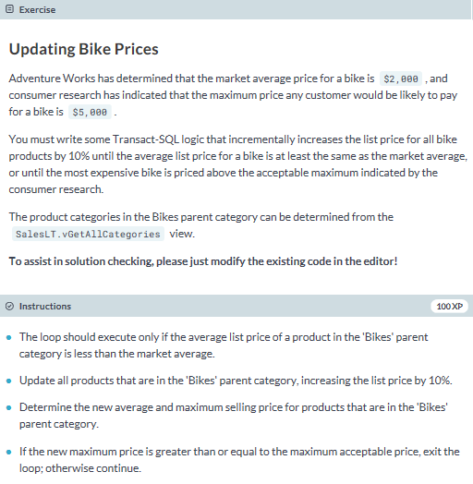

**DECLARE @MarketAverage money = 2000;**

**DECLARE @MarketMax money = 5000;**

**DECLARE @AWMax money;**

**DECLARE @AWAverage money;**

**SELECT @AWAverage = AVG(ListPrice), @AWMax = MAX(ListPrice)**

**FROM SalesLT.Product**

**WHERE ProductCategoryID IN**

**(SELECT DISTINCT ProductCategoryID**

**FROM SalesLT.vGetAllCategories**

**WHERE ParentProductCategoryName = 'Bikes');**

**WHILE @AWAverage < @MarketAverage**

**BEGIN**

**UPDATE SalesLT.Product**

**SET ListPrice = ListPrice * 1.1**

**WHERE ProductCategoryID IN**

**(SELECT DISTINCT ProductCategoryID**

**FROM SalesLT.vGetAllCategories**

**WHERE ParentProductCategoryName = 'Bikes');**

**SELECT @AWAverage = AVG(ListPrice), @AWMax = MAX(ListPrice)**

**FROM SalesLT.Product**

**WHERE ProductCategoryID IN**

**(SELECT DISTINCT ProductCategoryID**

**FROM SalesLT.vGetAllCategories**

**WHERE ParentProductCategoryName = 'Bikes');**

**IF @AWMax >= @MarketMax**

**BREAK**

**ELSE**

**CONTINUE**

**END**

**PRINT 'New average bike price:' + CONVERT(VARCHAR, @AWAverage);**

**PRINT 'New maximum bike price:' + CONVERT(VARCHAR, @AWMax);**